1)

a)

i)

null(AT) = span([1, -1, 0]T)

range(A) = span([1, 1, sqrt(3)]T, [-1, -1, 0]T)

null(A) = trivially empty

range(AT) = span([1, -1]T, [sqrt(3), 0]T)

ii)

Solve b = [2, 1, 1]T = x [1, 1, sqrt(3)]T + y [-1, -1, 0]T + z[1, -1, 0]T

x = 1/sqrt(3)

y = (-9+2sqrt(3))/6

z = 1/2

iii)

We get x1 - x2 = 2 and x1 - x2 = 1 so the system of equations is inconsistent.

iv)

Solve the normal equation ATAx = ATb. It is unique.

b)

i)

λ1 = 6

v1 = [2, -1]T

λ2 = 1

v2 = [1, 2]T

ii)9

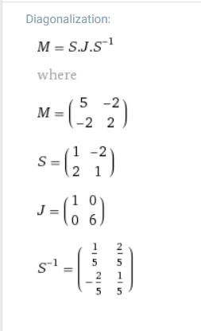

iii)

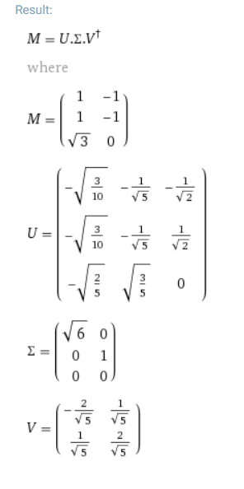

iv)Singular values: sqrt(6), 1 / l2 norm: sqrt(6)

c)

i)

Number of eigenvalues of a matrix = rank = number of non-zero values on the diagonal of the diagonal matrix. Explanation here: <https://math.stackexchange.com/a/1349914/372927>

ii)

Both matrices are symmetric

Both matrices have the same set eigenvalues and set of eigenvalues the same size from CW 2

For the otherwise, show B^TB has same rank as B, then substitute B for BB^T into that equality to show the same for BB^T. Proof in later past paper solutions (question comes up regularly).

2)

a)

i)

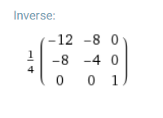

||A||1||A-1||1 = 5 * 5 = 25

||A||2||A-1||2 = sqrt(9 + 4sqrt(5)) * 1/sqrt(9-4sqrt(5))

||A||∞||A-1||∞ = 5 * 5 = 25

b i) No minimum points

ii) Stationary points at (⅓, 0) (Saddle) and (-1, 0) (Max)

iii) Saddle point at (1,-2)

c

i) TODO

ii)

This part is just using the definition of Laplace transformation.

iii)

Transform the equation using Laplace transformation, and we can solve for:

Y_1(s) = 1/(s^2 + 16)

Y_2(s) = -1/(s(s^2 + 16))

Then use partial fraction and the uniqueness of the Laplace transformation, we can get:

y_1(t) = ¼ sin(4t)

y_2(t) = 1/16 cos(4t) - 1/16

-----------